December 14th, 2008
Hi
Not much to write about. I heard on the radio news earlier that you are living under a state of emergency due to bad weather and power cuts.
I went to the Tuen Mun hospital for their check up on Wednesday. My nose had been bleeding a couple of weeks ago but clotted up normally just like any scratch/cut. The surgeons said that they could not tell anything from this without another biopsy. So when I go to the government dermatology clinic in a few weeks, I will tell them and probably arrange for another biopsy there (it is easier to get a biopsy there than at the hospital).
Chickens on a farm in Yuen Long got the bird flu virus and died. Analysis showed it to be the H5N1 strain. Consequently, about 80 000 chickens were culled at that farm and surrounding farms and at the wholesale market in Kowloon. It is suspected that the infection may have been introduced from fertilised eggs smuggled from China into HK.

The run yesterday was quite tough and was seven minutes slower than for the same run last year, though conditions for running were good. The breathing and running were tough and my legs felt like lead. I was also rather tired in the afternoon.
There has been another fatal accident on Mt Cook. Two Australian doctors from Perth were climbing in bad weather condition when one fell off a ridge down a steep slope.
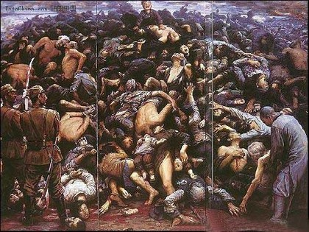
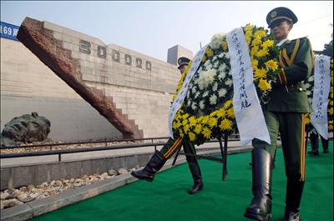
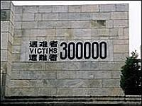
Yesterday (I think), was the 71st anniversary of the Nanjing massacre, when, in 1937, Japanese forces occupied what was then the capital of China and committed numerous atrocities on its civilian population. A ceremony took place in a newly renovated museum dedicated to the dead. China puts the number killed at more than 300,000, although Japanese estimates are far lower. [This is almost the same as I wrote in the least year’s letter and the pictures are the same.]
That’s about it for now.
Cheers

